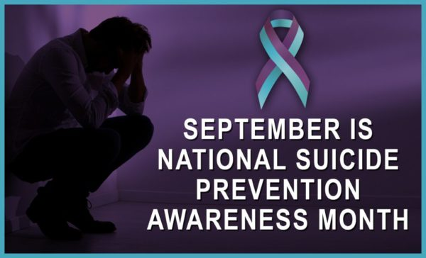
A Message From Forest Charter School's Counselor:
September, 2022
Dear Forest Charter Families,
Times have been tough! If you think your child may need additional mental health support, we want to help. Our Nevada City and Truckee sites now have mental health support available on a part-time basis. Our Nevada City counselor can be reached at (530) 265-4823; our Truckee counselor at (530) 550-7205. Our on-site counselors do not generally provide ongoing therapy for students, but they can help you find the resources your student needs. We also invite you to check out our new website at Forest Charter Counseling.
If your child is in crisis, every community provides a free 24-hour crisis service. Crisis counselors can help in an emergency (for example, if your teen is suicidal), and they will help you find ongoing support after the crisis has passed. If your family is facing domestic violence, there are additional 24-hour crisis lines dedicated to help. Contact numbers for crisis services in Truckee, Auburn/ Forest Hill, and Nevada City are listed first in our “Local Mental Health Resource” list.
Many families use their medical insurance to pay for non-emergency mental health services. You can contact your insurance company to request a list of providers who specialize in work with children or teens. Some insurance plans, like Medi-Cal, cover the cost of therapy completely. Ask your insurance company whether your plan includes a deductible or co-pay fee. Therapy may be more affordable than you think.
If you’re able to pay for counseling out of pocket, your options are extensive. Ideally, you can ask people you trust for recommendations. Your child’s doctor may be a good place to start. Your pediatrician can help identify any underlying medical issues and refer you to counseling support (they often have recommendations). Some medical clinics even offer counseling on site. Free and reduced-cost medical and mental health organizations are listed below the crisis contact numbers below.
LOCAL MENTAL HEALTH RESOURCES
Nevada City
• Nevada County Behavioral Health 24-hour crisis line (Grass Valley): (530) 265-5811
• Community Beyond [Domestic] Violence 24-hour crisis line (Grass Valley): (530) 272-3467
• Sierra Family Medical Clinic (North San Juan): (530) 292-3478
• Chapa De Indian Health Clinic (Grass Valley): (530) 477-8545
• Western Sierra Medical Clinic (Grass Valley): (530) 274-9762
• Nevada County Children’s Behavioral Health (Grass Valley): (530) 470-2736
Auburn/ Forest Hill
• Placer County 24-hour Child and Teen Help: (800) 852-8336 or (310) 855-4673
• Stand Up Placer County (Domestic Violence 24-hour Hotline): (530) 575-5352
• Chapa-de Indian Health Program (Auburn): (530)887-2800
• Western Sierra Medical Clinic (Auburn): (530) 537-3000
• Placer County Children’s System of Care (Auburn): (530) 889-6700
Truckee
• Nevada County Behavioral Health 24-hour crisis line (Truckee): (888) 801-1437
• Tahoe Safe Alliance 24/7 (Domestic Violence 24-hour Hotline): (800) 736-1060
• Western Sierra Medical Clinic (Kings Beach-Tahoe): (530) 584-9762
• Nevada County Children’s Behavioral Health (Truckee): (530) 582-7803
NATIONAL MENTAL HEALTH RESOURCES
National Suicide Prevention Crisis Line 800- 273-TALK (8255)
Crisis Text Lines
- Text BRAVE to 741-741 24/7 support. Text from anywhere in the United States, anytime, about any type of crisis. A real-life trained, volunteer, crisis counselor will receive the text.
- Text TEEN to 839863
- Trevor Lifeline (LGBTQ Youth) CALL 866-488-7386 Text START to 678678, or chat online https://www.thetrevorproject.org
Free Self-help Resources
- suicideispreventable.org
- gritx.org
Please let us know if there’s anything else we can do to help support your child’s mental health.
Emily Gallup Dyan Johnson
(530) 559-0101 (404) 323-1878
egallup@forestcharter.com djohnson@forestscharter.com

